Feature Selection- Process of selecting useful features and ignoring or removing useless or redundant features. There are two main types of feature selection supervised or unsupervised.

Supervised methods may be divided ii, filter and intrinsic. Filter based feature selection methods use statistical measure to score the correlation or dependence between input variables that can be filtered to choose the most relevant features.

Statistical measure for feature selection must be carefully chosen based on the data type of the input variable and the output or response variable.

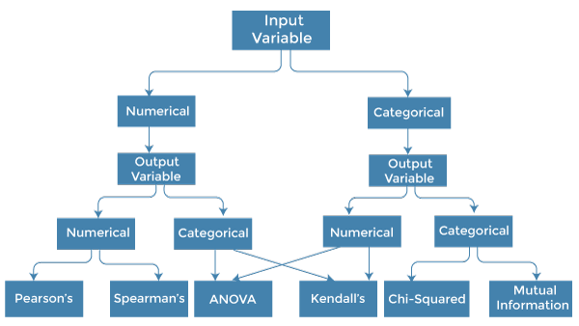

Summary of feature selection method:

Feature selection- Select a subset of input feature from the dataset.

Unsupervised- Do not use the target variable (e.g. remove redundant variables)

Supervised- Use the target variable ( e.g. remove the irrelevant variables).

Wrapper- Search for well performing subsets of features.

RFE- Recursive Feature Elimination

Filter- Select subsets of feature based on their relationship with the target.

Intrinsic- Algorithms that perform automatic feature selection during training.

Statistics for filter based feature selection methods-